touch open

Sudo apt-get install

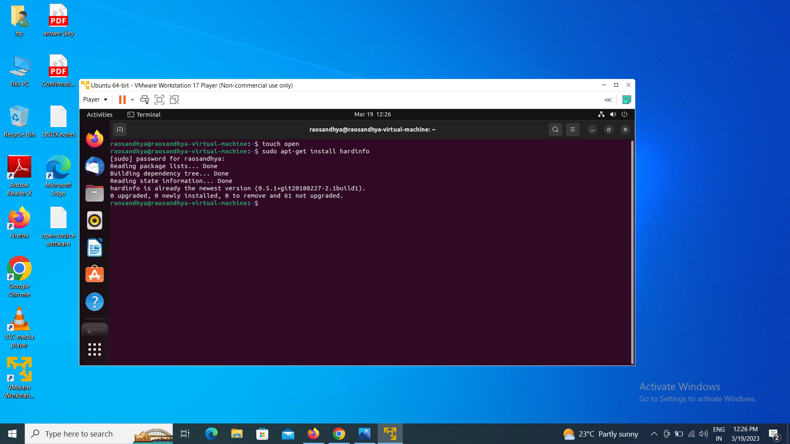

hardinfo

